# Project report on “QUIZ GAME”.

Project name: Quiz Game

Submitted to: Md. Mostafijur Rahman

Lecturer & Student Advisor

Department of computer science & engineering

University of Barisal

Submitted by: Sadia Afrin Tarin

Class Roll: 18CSE039

Exam Roll:CSE027

Session:2017-18

# Letter of transmittal

I declare that this project report on “QUIZ GAME” is submitted to Md. Mostafijur Rahman Sir, Our project manager & our student advisor. This documentation has done under the guidance of Md. Mostafijur Rahman Sir. For this I am so much thankful to him. This is certified that I did this documentation under CSE-1104 course and it is also certified that this documentation has not been submitted elsewhere for the requirement of any degree or for any other purposes.

# Acknowledgement

I am using this opportunity to express my gratitude to everyone who supported me throughout this project. I have the deepest appreciation to them for providing me the possibility to complete this project. I am highly indebted to Md. Mostafijur Rahman, our project supervisor for his guidance and constant supervision. I am also thankful to my dear classmate Al Shahrior Tonmoy & Sourav Malo for their aspiring guidance. I would also like to thank my friends who helped me a lot in finalizing my project within the limited time frame.

# Abstract

The main objectives of my projects are to play a very exciting quiz game using C programming language. This program is based on some operation levels. By using this program one can enjoy a exciting game as well as enrich his/her general knowledge.

Contents

Project report on “QUIZGAME”. 1

Letter of transmittal 2

Acknowledgement 3

Abstract 4

1. Introduction 6

2. Project scheduling 6

3. Problem statement, Purpose and objectives 6

4. Proposed solution 6

5. Assumptions and constraints 7

5.1 Hardware 7

5.2 Software 7

6. Source code 7

7. Project Screenshot..............................................................................................................................16

8. User Manual......................................................................................................................................20

9. Conclusion 20

# Introduction

The name of my project is “ QUIZ GAME”. It is very enjoyable for game lover & knowledge seeker people. It is so easy to play knowledge acquiring using my project. One can record one’s highest score by using this project. Again one can see the highest score secured by someone. There are three continuous levels in this game. Easy, Medium & Hard. In every level there are 10 questions. You havr to give at least 6 correct answers in each level, to go to the next level. I have done this project by the help of my course teacher & my project manager Md. Mostafijur Rahman, sir. So, I am very thankful & grateful to him for his kindness.

# Project scheduling

|  |  |  |
| --- | --- | --- |
| No. | Items | Date |
| 1 | Project proposal | 24-07-2018 |
| 2 | Project presentation | 21-08-2018 |
| 3 | Project documentation | 21-08-2018 |
| 4 | Project report | 16-09-2018 |

I have done all the things under the above scheduling & am thankful to my course teacher & project manager Md. Mostafijur Rahman for all kind of his help.

# Problem statement, Purpose and objectives

The name of my project is quiz game. In this project there will be options for starting the game, view high score, view help & exit the program. By this it will be very easy to learn something new in a very short time

# Proposed solution

I have done a project named quiz game. I have been followed the algorithm & flowchart to solve the problem. I have taken some help from my course teacher & project manager Md. Mostafijur Rahman. By using this project one can easily enjoy a very exciting game.

I have used C programming language to solve my project.

# Assumptions and constraints

## 5.1 Hardware

1. Mouse

2. Monitor

3. Keyllboard

4.PC

5.Printer

## 5.2 SOFTWARE

1.Codeblocks

# 6. SOURCE CODE

#include<stdio.h>

#include<string.h>//toupper

#include<stdlib.h>// exit

#include<time.h>//difftime

struct game {

char qus[1000];

char ans;

};

void help(){

system("cls");

printf("This game is very easy to play.\nYou will be asked some questions.\n");

printf("You have to choose the right answer among the four options provided.\n");

printf("There are three levels in this game- EASY, MEDIUM & HARD. In each level there are 10 questions.\n");

printf("You have to give at least 6 correct answer in each level to go to the next level.\n");

printf("Your score will be calculated & displayed at the end.\n");

printf("\nIf you secure highest score, your score will be recorded.\n");

printf("Remember that the more quicker you give answer the more score you will secure.");

printf("To start the game press 1.\n\t\t****Best of Luck****\n");

}

void display_score(){

char name[30];

float scr;

FILE *file;

system(“cls”);

file=fopen("score.txt","r");

fscanf(file,"%s %f",&name,&scr);

printf("\n\n\t %s has secured the highest score %.2f \n ",name,scr);

fclose(file);

getch();

}

void write_score(float score,char player[30]){

float sc;

char nm[30];

FILE *file;

system("cls");

file=fopen("score.txt","r");

fscanf(file,"%s %f",&nm,&sc);

if(score>=sc){

sc=score;

fclose(file);

file=fopen("score.txt","w");

fprintf(file,"%s\n%.2f",player,sc);

fclose(file);

}

}

int main()

{

int choice,i,flag;

float score=0;

int count_qus,count_right_ans;

char player_name[30];

time_t start_time,end_time;

struct game quiz[30];

system("cls");

mainhome:

system("cls");

printf("\n\n\t\tEnter Your Name:");

gets(player_name);

system("cls");

printf("\t\t************************************\n");

printf("\t\t************************************\n");

printf("\t\tWelcome %s To Quiz Game\n",player_name);

printf("\t\t************************************\n");

printf("\t\t************************************\n\n\n");

printf("\tWhat do you want to do?\n\t");

printf("1.Start game\n\t2.High score\n\t3.Help\n\t4.Quit game\n");

printf("Enter any of the above number to do your desired action\n");

scanf("%d",&choice);

if (choice==2){

display_score();

goto mainhome;

}

else if(choice==4){

exit (1);

}

else if (choice==3){

help();

goto mainhome;

}

else if (choice==1){

system("cls");

home:

system("cls");

start_time=time(NULL);

count_qus=count_right_ans=0;

flag=0;

strcpy( quiz[0].qus,"\t\t\t1. Which of the following is most oriented toward scientific programming ?\n\n\t\t\ta)Cobol\tb)Fortran\n\t\t\tc)C++\td)Basic\n\n");

strcpy( quiz[1].qus,"\t\t\t2. What kind of file extension .mpg?\n\n\t\t\ta)Movie file\tb)Image file\n\t\t\tc)Text file\td)Audio file\n\n");

strcpy( quiz[2].qus,"\t\t\t3. Who was the first US President?\n\n\t\ta)Richard Nikson\tb)Abraham Linkon\n\t\tc)John F. Kennedy\td)George Washington\n\n");

strcpy( quiz[3].qus,"\t\t\t4. Which country won the FIFA world cup in 2014?\n\n\t\ta)France\tb)Spain\n\t\tc)Germany\td)Belgium\n\n");

strcpy( quiz[4].qus,"\t\t\t5. What is the height of Mount everest in feet?\n\n\t\ta)8648\tb)8848\n\t\tc)8484\td)8684\n\n");

strcpy( quiz[5].qus,"\t\t\t6. Who was the only player to score 6 successive sixes in an over?\n\n\t\ta)Adam Gilchrist\tb)M.S.Dhoni\n\t\tc)Sanath Jayasurya\td)Herschel Gibbs\n\n");

strcpy( quiz[6].qus,"\t\t\t7. Which country is Maria Sarapova from?\n\n\t\ta)Russia\tb)Argentina\n\t\tc)Spain\td)America\n\n");

strcpy( quiz[7].qus,"\t\t\t8. Which city is known at 'The City of Seven Hills'?\n\n\t\ta)Madrid\tb)Rome\n\t\tc)Vatican city\td)Italy\n\n");

strcpy( quiz[8].qus,"\t\t\t9. Which of he following is a web browser?\n\n\t\ta)Maya\tb)Flash\n\t\tc)Netscape navigator\td)Dreamweaver\n\n");

strcpy( quiz[9].qus,"\t\t\t10. Which of the following is a Palindrome number?\n\n\t\ta)1234\tb)9876\n\t\tc)12321\td)9999\n\n");

strcpy( quiz[10].qus,"\t\t\t11. Which of the following countries has signed a 'Non- Aggression Pact' with Sudan ?\n\n\t\ta)South Sudan\tb)South Africa\n\t\tc)Uganda\td)Ethiopia\n\n");

strcpy( quiz[11].qus,"\t\t\t12. The sensitive index of national stock exchange of India is popularly known as?\n\n\t\ta)CRIS\tb)MICS\n\t\tc)SENSEX\td)NIFTY\n\n");

strcpy( quiz[12].qus,"\t\t\t13. Which of he following is a read only memory storage device ?\n\n\t\ta)Flash drive\tb)Floppy disk\n\t\tc)Hard disk\td)CDROM\n\n");

strcpy( quiz[13].qus,"\t\t\t14. The International Rice Research Institute is located in ?\n\n\t\ta)Indonesia\tb)Philippines \n\t\tc)Malaysia\td)Thailand\n\n");

strcpy( quiz[14].qus,"\t\t\t15. Which movie is the highest grossing movie of Bangladesh of all time?\n\n\t\t\ta)Beder Meye Josna\tb)Boss 2\n\t\t\tc)Hero the Superstar\td)Dhaka Attack\n\n");

strcpy( quiz[15].qus,"\t\t\t16. What is the maximum no. of asymptotes of the curve x^4+2x+6=0? ?\n\n\t\ta)Infinite\tb)3\n\t\tc)4\td)None\n\n");\

strcpy( quiz[16].qus,"\t\t\t17. Who was awarded the 'Man of the Tournament' of ICC WORLD CUP 2007?\n\n\t\ta)Mahela Jawardan\tb)Glen Magrath\n\t\tc)Sachin Tendulkar\td)Mathew Hayden\n\n");

strcpy( quiz[17].qus,"\t\t\t18. What is the headquarter of Western Development Region?\n\n\t\ta)Kathmandu\tb)Dhangadhi\n\t\tc)Dhankuta\td)Pokhara\n\n");

strcpy( quiz[18].qus,"\t\t\t19. Who was the first female actress in Bengali film?\n\n\t\ta)Shabana \tb)Hrituporna\n\t\tc)Bonani Chowdhury\td)Bonolota sen\n\n");

strcpy( quiz[19].qus,"\t\t\t20. How many districts are broadened by The Sundarban in Bangladesh ?\n\n\t\ta)4\tb)5\n\t\tc)6\td)7\n\n");

strcpy( quiz[20].qus,"\t\t\t21. Who is the first Secretary general of United Nations from Asia?\n\n\t\ta)Uthant\tb)Kofi Anan\n\t\tc)Ban ki moon\td) Trigveli\n\n");

strcpy( quiz[21].qus,"\t\t\t22. Who / Which organization was awarded the Nobel Peace Prize in 2017 ?\n\n\t\ta)NAM\O\tb)ICAN\n\t\tc)Kajuo Isiguro\td)Malala Yusuf\n\n");

strcpy( quiz[22].qus,"\t\t\t23. What is the position of Dhaka in mega city?\n\n\t\ta)11\tb)13\n\t\tc)9\td)7\n\n");

strcpy( quiz[23].qus,"\t\t\t24. Who was the founder of 'Star Mosque'?\n\n\t\ta)Islam Khan\tb)Mirja Golam\n\t\tc)Humayun\td)Sher Shah\n\n");

strcpy( quiz[24].qus,"\t\t\t25. Whgo is the composer of the song 'Khachar vetor ochin pakhi' ?\n\n\t\ta)Abdul Latif\tb)Abu Zafor\n\t\tc)Gobindo Halder\td)Lalon Shah\n\n");

strcpy( quiz[25].qus,"\t\t\t26. Who is considered as the fastest women in Bangladesh?\n\n\t\ta)Selina Hossain\tb)Roksana Akter\n\t\tc) Sirin Akter\td)Joya Chowdhury\n\n");

strcpy( quiz[26].qus,"\t\t\t27. Which city is the highest city of the world?\n\n\t\ta)Woen Chuan\tb)Pataya\n\t\tc)New York\td)Mumbai\n\n");

strcpy( quiz[27].qus,"\t\t\t28. Which day is celebrated as 'World AIDS Day'?\n\n\t\ta)1st january\tb)1st december\n\t\tc)3rd january\td)3rd december\n\n");

strcpy( quiz[28].qus,"\t\t\t29. 'Mohammad Ali' is from which country?\n\n\t\ta)Russia\tb)France\n\t\tc)Britain\td)America\n\n");

strcpy( quiz[29].qus,"\t\t\t30. Who was the 1st competitor of OLYMPIC from Bangladesh?\n\n\t\ta)Kazi Salauddin \tb)Jakaria Pintu\n\t\tc)Niaz Morshed\td)Saidur Rahman\n\n");

quiz[0].ans='B';

quiz[1].ans='A';

quiz[2].ans='D';

quiz[3].ans='C';

quiz[4].ans='B';

quiz[4].ans='B';

quiz[5].ans='D';

quiz[6].ans='A';

quiz[7].ans='B';

quiz[8].ans='C';

quiz[9].ans='C';

quiz[10].ans='A';

quiz[11].ans='C';

quiz[12].ans='D';

quiz[13].ans='B';

quiz[14].ans='A';

quiz[15].ans='C';

quiz[16].ans='B';

quiz[17].ans='D';

quiz[18].ans='C';

quiz[19].ans='B';

quiz[20].ans='A';

quiz[21].ans='B';

quiz[22].ans='C';

quiz[23].ans='B';

quiz[24].ans='D';

quiz[25].ans='C';

quiz[26].ans='A';

quiz[27].ans='B';

quiz[28].ans='D';

quiz[29].ans='D';

for (i=0;i<30;i++){

printf("\n\n%s\n\n",quiz[i].qus);

count_qus++;

printf("Your answer is:\n");

if (toupper(getch())==quiz[i].ans){

printf("CORRECT ANSWER!!!!!\n\n");

count_right_ans++;

flag++;

}

else {

printf ("Wrong Answer. Correct answer is %c\n\n",quiz[i].ans);

}

if(count_qus==10 && count_right_ans>=6){

system("cls");

printf("\tCongratulations.....\n\tYou have crossed Easy Level...\n\n");

printf("\t\tWelcome to Medium Level\n");

printf("\t\t***********************");

flag=0;

}

if(count_qus==20 && flag>=6){

system("cls");

printf("\tCongratulations.....\n\tYou have crossed Medium Level...\n\n");

printf("\t\tWelcome to Hard Level\n");

printf("\t\t*********************");

}

if(count_qus==10 && count_right_ans<6 || count_qus==20 &&flag<6){

break;

}

}

end_time=time(NULL);

score=(float)count_right_ans/count_qus*100-difftime(end_time,start_time)/3;

if(score<=0) score=0;

printf("\n\n\nYour Score: %.2f",score);

if (score==100){

printf("\n\nEXCELLENT!!! YOU ARE REALLY SO MUCH BRILLIANT. KEEP IT UP\n");

}

else if (score>=80 && score<100) {

printf("\n\nVERY GOOD!!!YOU ARE QUITE BRILLIANT.\n");

}

else if (score>=50&&score<80){

printf("\n\nGOOD!!! BUT YOU NEED TO KNOW MORE. KEEP TRYING\n");

}

else if (score>=30 && score<50){

printf("\n\n NOT SATISFACTORY RESULT. WORK HARD.\n");

}

else{

printf("\n\nYOU ARE VERY POOR IN G.K. BETTER LUCK NEXT TIME.\n");

}

puts("\n\n DO YOU WANT TO PLAY AGAIN?\n(Y/N)");

if (toupper(getch())=='Y') goto home;

else

{

write_score(score,player_name);

goto mainhome;

}

}

return 0;

}

# 7..Project screenshot

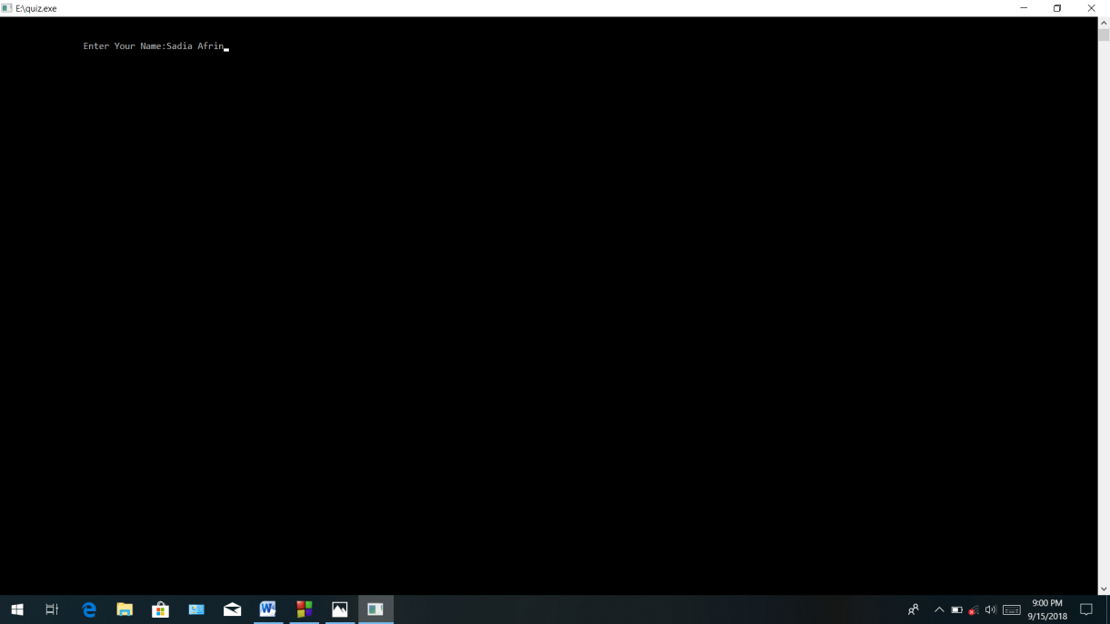

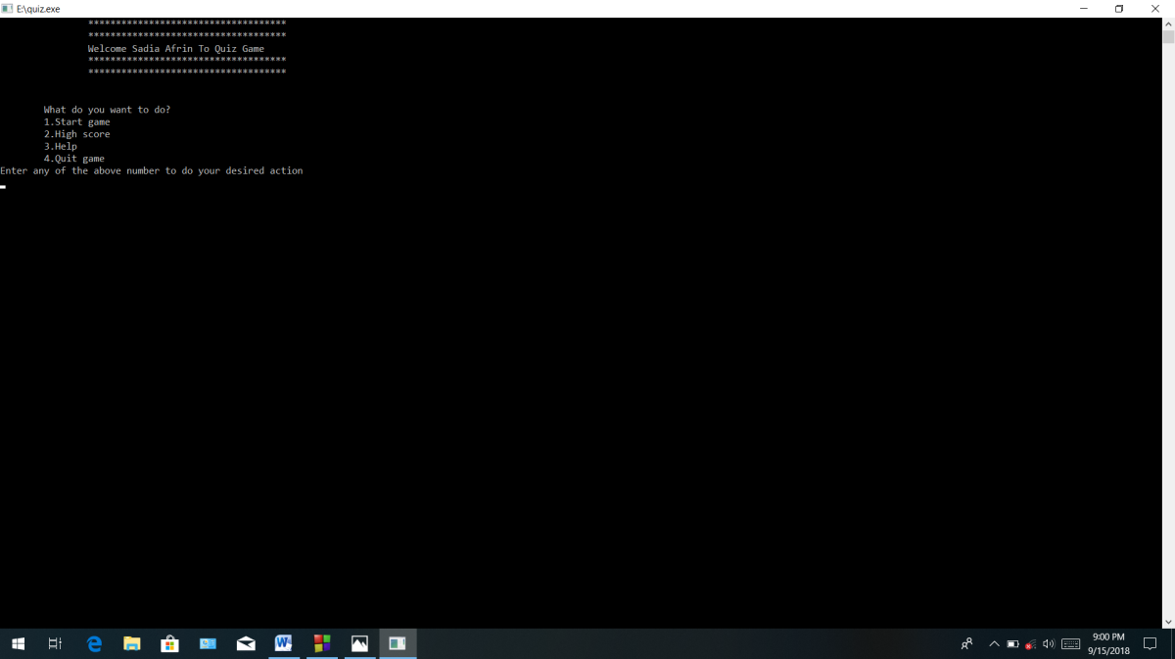

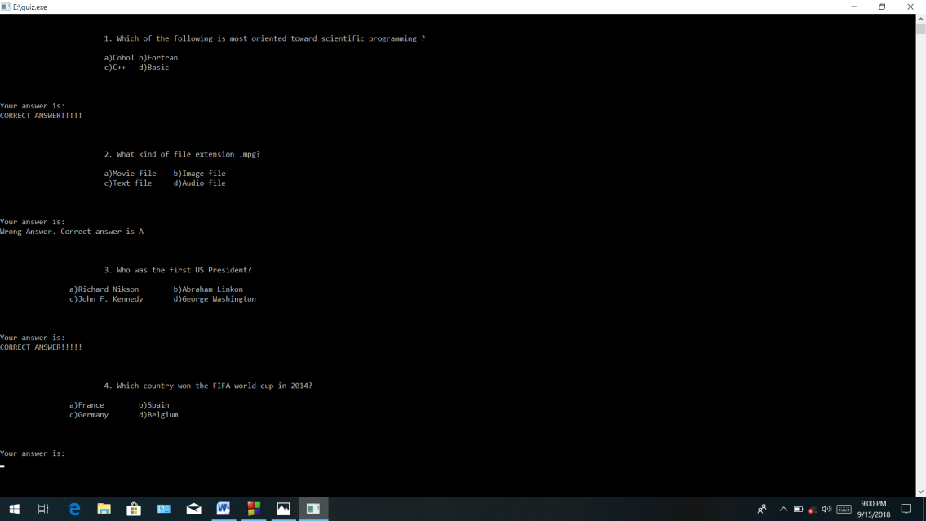

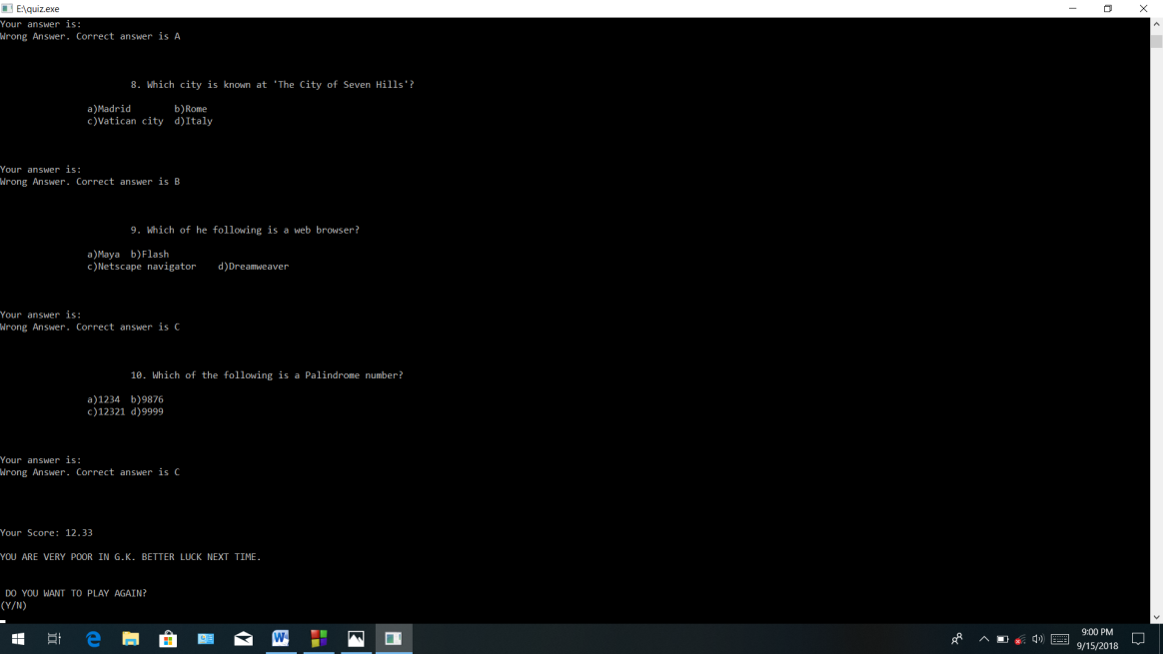

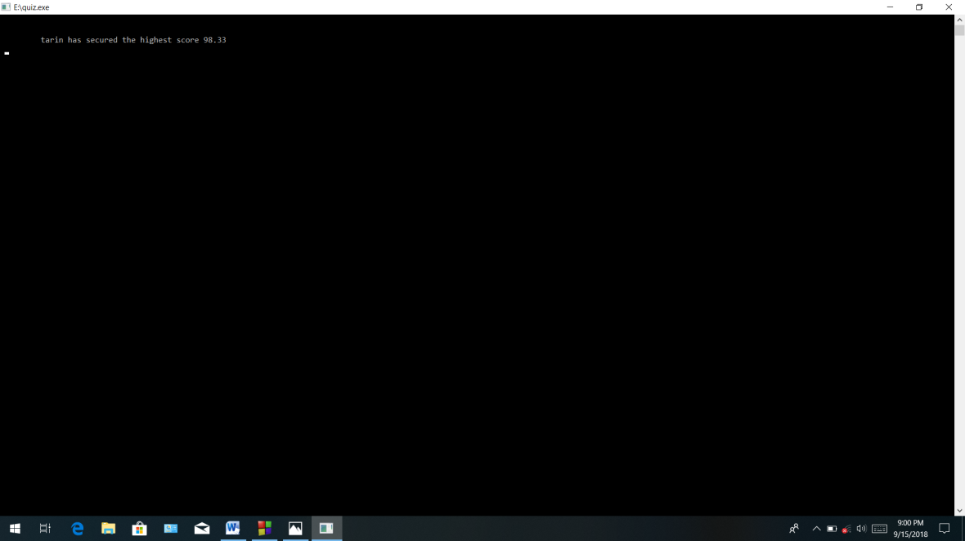

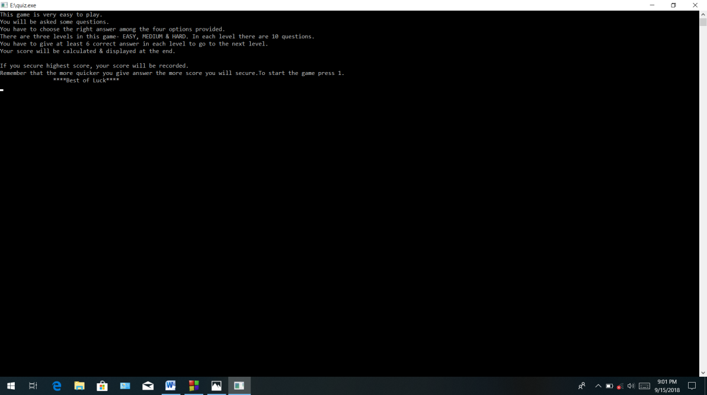

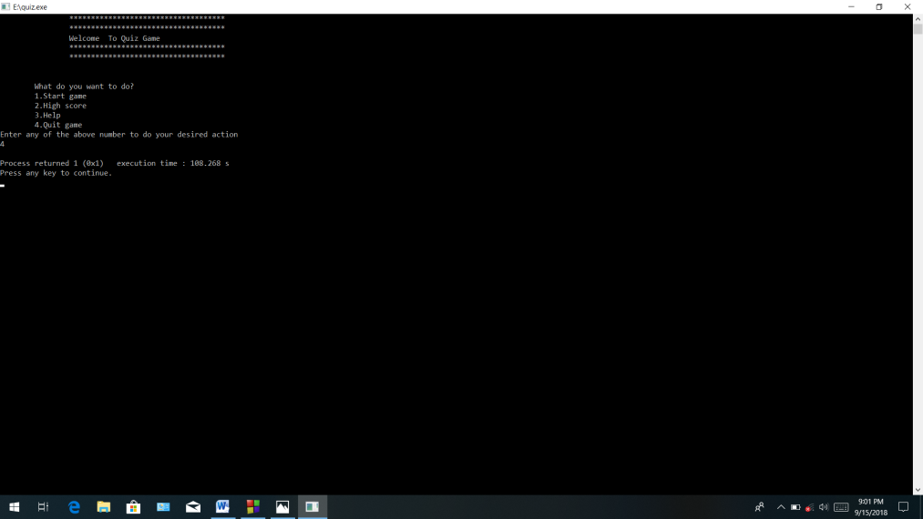

# User manual

One have to fulfil some process for using this project. At first he/she has to build & run this project’s C programming code in codeblocks.

After that he/she can see a curser where he/she can see a sentence like” press any key to continue…..” Then he/she has press any baton from his device. After that he/she can see a main menu. In this menu there are lots of menu is available . Then he has to put the menu no. what he/she wants to do. By doing all the task one can easily use this project.

The project is so much enjoyable and a small source of acquire knowledge.

# Conclusion

The main objectives of this project are to help people to acquire knowledge through entertainment. This program is written using C Programming Language. I use file, loop, functions, string, library conditions ,structure etc. to make up my project.